Rapid Reading 1

Spring 2020

Student Resources

1. Orientation
You have probably decided to take this course because you want to get better at reading more quickly and getting more information when you read quickly. Hopefully, this is something that you will be able to do by the end of the course.

Goals

What are your goals for this course? Be exact in your answer and it will be easier for your teacher to help you to realise your goals.

My goals

The course is structured in three main strands: topic, strategy, text organisation. Your teacher will also do some work with you on vocabulary every week based on the New General Service List. The topics are interwoven and will be spread apart. This is because you need time to forget new words to strengthen your memory of them. The strategies and text organisation will be useful throughout but teaching every strategy and text organisation method in one lesson is impractical, so they are spread throughout the course.

The benefits of reading

There are several benefits, or good points, of reading. However, before you read about them, what do you think the benefits of reading are?

I think some of the benefits of reading are:

Next, look at the reading text. This is a practice run on how you should try to read in the classroom sessions.

Discussion

What was difficult for you when reading the text? Why?

What could make the text easier to understand?

2. Fan Fiction 1

In today’s lesson you will read 3 pieces of fan fiction. Fan fiction is creative writing by fans of book series, television or film series, pop groups or even video game characters. The fans write stories about the characters and post their stories on internet sites for other fans to read.

Today you will

- find common features between the pieces of fan fiction;
- decide which piece of fan fiction you like most and why; and,
- plan an internet search to find some different fan fiction that you are curious about or interested in reading.

Brainstorming

First, what kinds of fan fiction do you think there are? Brainstorm your ideas below.

What phrases do you think you will encounter (see)?

Words | Phrases

You will now read some fan fiction texts that your teacher has prepared.

Theme and Rheme

In any sentence we have a theme, which is the main topic of the sentence, and a rheme, which is the comment of the sentence. The easiest way to think of it is that the theme is usually the first noun, pronoun or verb, and the rheme is everything after it. Basically, the theme helps to keep the sentence in the context, or current bit of meaning.

Find the theme and rheme in these sentences. Circle the theme and underline the rheme.

- teacher is not Japanese.

Your
- The sea was grey and so was the sky.
- What time is it?
- Flying south at this time of year is dangerous but necessary for birds.
- Feel good about yourself.

There are two basic theme and rheme patterns.

Theme 1, Rheme 2. Theme 2, Rheme 3. Theme 3, Rheme 4.

Theme 1, Rheme 2. Theme 1, Rheme 3. Theme 1, Rheme 4.

What are the theme and rheme patterns of the texts you read. Choose one paragraph from each.

Text | Theme and rheme pattern
1
2
3

You might find it easier to get information about characters and places in texts if you understand how theme and rheme work.

Discussion

What common features of fan fiction did your class find?

Which piece of fan fiction did you like the most? Why?

What kinds of fan fiction are you interested in reading? What will you search for outside of class? What search terms will you use?

3. Travel Writing 1

In today’s class you will read some travel writing. Do you often read travel writing?Have you ever read travel writing in English?

Today you will

- predict text meaning and organisation using genre knowledge;
- guess synonyms (words that have the same meaning) based on the place in a sentence and way the words are used; and,
- use strategies you have used before.

If you have read travel writing, what features do you normally encounter in travel writing? If you don’t, what features would you expect in English travel writing?

Talk to your partner, share your ideas and make a list of up to six features that you expect.

You will read the first text of the lesson next. As usual, read quickly, taking notes in the margin of your note sheet. After you finish, check your list of features that you made. Which of your features were in the text? Highlight the ones that were in your text.

Synonyms

Synonym knowledge is very extremely useful when you are reading because writers authors use different alternative word choices to keep their texts interesting compelling.

Search through the first text for some words that you do not know. Pick the six most important ones to you. Try to guess synonyms for the words, then check them in your thesaurus (you probably have the Dictionary.com app installed on your phone, which has a thesaurus, or a synonym dictionary).

Unknown word | Synonym(s) I am guessing | Correct? Meaning.

How successful were you at guessing synonyms? What could help you improve?

Continue reading the second and third texts, guessing synonyms as you go.

Analysis

What are the common features across all three travel texts? Work with your partner to do this because it is a lot of work. If you are not sure, write it down and check with your teacher.

Discussion

Did you enjoy reading the travel writing? Give reasons for your answer and other class members’ answers.

Would you like to read travel writing in your free time? Where else would you like to read about?

4. Fan Fiction 2

In this lesson, use what you have already learnt about fan fiction in order to read quickly and get information faster.

What are some features of fan fiction you have seen, either in lesson 2 or in your own reading outside of the class?

What difficulties have you encountered in reading fan fiction? How can you overcome these difficulties?

What strategies have you studied so far?

Today you will

- predict a text using genre knowledge;
- use reference to understand sentences: and,
- use strategies you have used before.

Look at the title of the first text. What do you expect from the text? Work with a partner, share your ideas and write them below.

Next read the first text. Were you correct in your predictions (were your ideas correct)? Go back to page 7 and page 12. Which features did you use to help you predict?

Reference
Reference comes in three kinds: anaphoric reference (reference to things written earlier in the text), cataphoric reference (reference to things written later in the text), and exophoric reference (reference to things outside the text, usually shared cultural knowledge). Reference is usually given with pronouns or noun phrases.

Mark the pronouns used for reference with A (anaphoric), C (cataphoric) or E (exophoric). Draw arrows or write underneath what the pronouns refer to.

He knew, before he had been in Sunderland half an hour, that they meant to spoil him. With his baggy clothes and his bitten nails, his nervousness and restlessness, anybody could tell something was wrong. He wasn’t like them; they stride along the seafront, carefree. They came in by train from Seaham every fifteen minutes, mooched down Sea Road, pointing at the pubs: the summer sun bounced off the pavements, the houses echoed the laughter his ears like the audience for a bawdy comedian; boy racers along the coast, drums thumping, flower planters and stray Coke cans, and the smells of the chip shop mixed with the North Sea spray.

Now look at the first two texts again and find the references in the longest paragraph in each one.

Next, read the final text and use reference knowledge to help you read quickly, as well as other techniques and strategies you have learned so far.

Discussion

Have you enjoyed reading fan fiction? What are the reasons for this?

Do you have any problems reading fan fiction? What can you do to solve them?

Which strategies and skills for reading have been most useful for you so far? Why?

5. Travel Writing 2
You’ve already read some of the finest travel writing that the English language has to offer. It contained several features unique to the genre, which you already listed in week 3. Additionally, you took a stab at several synonyms.

Refresh your memory by jotting down the features of travel writing.

Take your abilities further by remembering the skills you have learnt on the course so far.

Today you will:
- guess phrasal verbs by preposition;
- start to learn noun-verb collocation with SkELL; and,
- apply all strategies learned so far.

First, apply the skills and knowledge you have already learned above to the first text of today’s lesson.

Guessing Phrasal Verbs
You already know phrasal verbs, verb phrases usually made from two or three words. The end of a phrasal verb is a preposition, a word that indicates space, time and relationships. Prepositions are useful when guessing phrasal verbs. Below are the fifteen most common phrasal verbs in English. Next to each one, write V if the verb helps you know the meaning more, or write P if the preposition helps you know the meaning more.

Go on |  | Find out | V | Set up
Pick up |  | Come out |  | Turn out
Come back |  | Go out |  | Get out
Come up |  | Point out |  | Come in
Go back |  | Grow up |  | Take on

Next, find the phrasal verbs in today’s first text and guess the meaning of each one.

Phrasal Verb | Guess | Meaning

Which phrasal verbs were the easiest to guess? Which were more difficult? Why?

Noun-Verb Collocation
You have a very useful tool available in SKELL (http://skell.sketchengine.co.uk/), which is based on a collection of internet texts that contains over a billion words. You can type in any word and find the words it collocates with (can often be found together with). This is most useful with nouns and verbs. With a partner, choose ten words from the first text, five nouns and five verbs (five words per person), and find their top three subjects and objects, or verbs that have the noun as a subject or object. To do this, click Word Sketch.

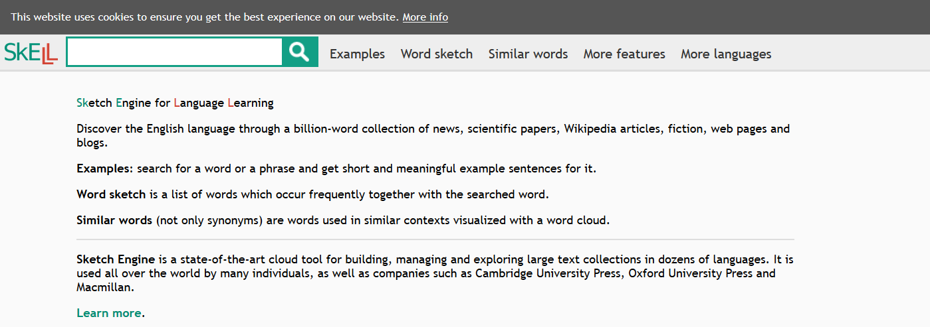Fig 1. SKELL Start page

You can also see these combinations in examples by clicking the words.

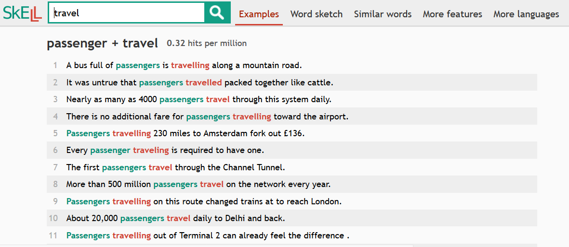
Fig 2. SKELL Examples page

My SKELL Research

Word | Subject/Verb with subject | Object/Verb with object

Don’t forget to copy your partner’s work.

Discussion

Have you enjoyed reading travel writing? What are the reasons for this?

Do you have any problems reading travel writing? What can you do to solve them?

What are the most useful strategies you have learnt so far on the course? Why?

6. Language Study
This is going to be good practice for your midterm review next week. The midterm will have varied texts and you will need to use all of the strategies and skills you have learned to complete it within the time allowed. Before you begin, think of all of the strategies and skills you have learned on the course.

Ways of thinking about reading | Ways of understanding new language

Discourse skills and strategies review

Before you read the first text, with a partner, plan how you will read it, based on what you have learned in previous lessons.

My plan (before reading) | What problems I had (after reading)

Check with your teacher to see if they have any ideas that might be different, or that can help you with your problems.

Now do the same thing with the second and third texts.

My plan (before reading) | What problems I had (after reading)

My plan (before reading) | What problems I had (after reading)

Next week you have your midterm review so make sure that you check your notes and practice reading outside class.

8. Internet language

What do you know about internet language? Are there any words you see often that you don’t understand? How many of the abbreviations (shortened words or phrases) below do you know?

smh |  | atm
idk |  | icymi
brb |  | tl;dr

What other internet abbreviations or words do you know?

Today you will:
- learn to discard unnecessary information;
- find collocates of new vocabulary; and,
- use strategies and skills taught previously.

Read today’s first text and see how quickly you can read it to get information from it.

Discard unnecessary information
Read the following paragraph from a blog. Black out all of the unnecessary information with a marker or a pencil. Make it difficult to read because this will reduce the distraction. (Don’t worry. You won’t need to do this every time.)

You get your schedule for the new teaching year. You have a new course to teach. Oh no! How much work?! Yes, it is a lot. Hopefully I can help streamline out the panic. Learn from my mistakes instead of your own.

Getting Started

What kind of course is it? Is it discrete skills, a mish-mash of skills, content, or merely an idea crafted by nymphs from a gossamer of buzzwords? This is going to dictate a lot about how you approach it.

If it’s all four skills, what can’t the learners do yet that you want them to do? If you aren’t sure, ask or have a good think. What kinds of people are your learners? Pope-Ruark (2018) advocates creating stakeholder profiles for your course. Put yourself in these different people’s shoes. Make them as realistic as possible. ‘Talk’ to them in your head. Ask questions to them and let them answer your questions and it makes this process easier. Yes, I know this sounds like the ravings of a man possessed but trust me here, or give it a try and if you don’t like it, try it your way.

Reread the first text again. Can you find any information that is not useful? Don’t be afraid to use your notes to help you.

It is totally fine to skip through texts quickly if you think that parts of them are not useful. By reading the first line and the last line of a paragraph, you can quickly get an idea of how useful it is.

New vocabulary collocates

You have used SKELL to search for noun and verb collocates already. However, you can also search for adjectives and adverbs, in fact any other word to find its collocates. Choose five words that you don’t know from today’s texts. Choose any four collocates and write a memorable example sentence for each one.

New SKELL VOCABULARY

New word | Collocate | Example

Discussion

What are the main points of today’s texts? What can you add to them from your own experience?

Point | My experience

Are there any points that you disagree about? Why?

Are there any ways that internet language is different in languages that you use other than English?

9. Business 1

One of the biggest reasons that adults in Japan want to learn English is because they think it may be useful for work. Have you ever needed to use English at a part-time job? Have you ever needed to read English at a part-time job?

What do you think some features of business texts in English are?

Today you will:
- use text organisation to summarise quickly;
- learn how to find N-grams to learn formulaic phrases; and,
- use previously taught skills and strategies.

Look at the first text. How is it organised? In 50 seconds, read the first and last sentence of all the paragraphs. What are the topics of these paragraphs?

Text organisation

1
2
3
4
5

Write a 25-word summary of the first text.

N-Grams (Formulaic phrases)

You have already used SKELL. Now, meet SketchEngine Open Corpora. This is an even more powerful corpus (collection of texts) tool, with more corpora (plural of corpus). You are going to search for formulaic language using N-Grams. N-Grams are groups of words that are commonly found together.

https://app.sketchengine.eu/#open

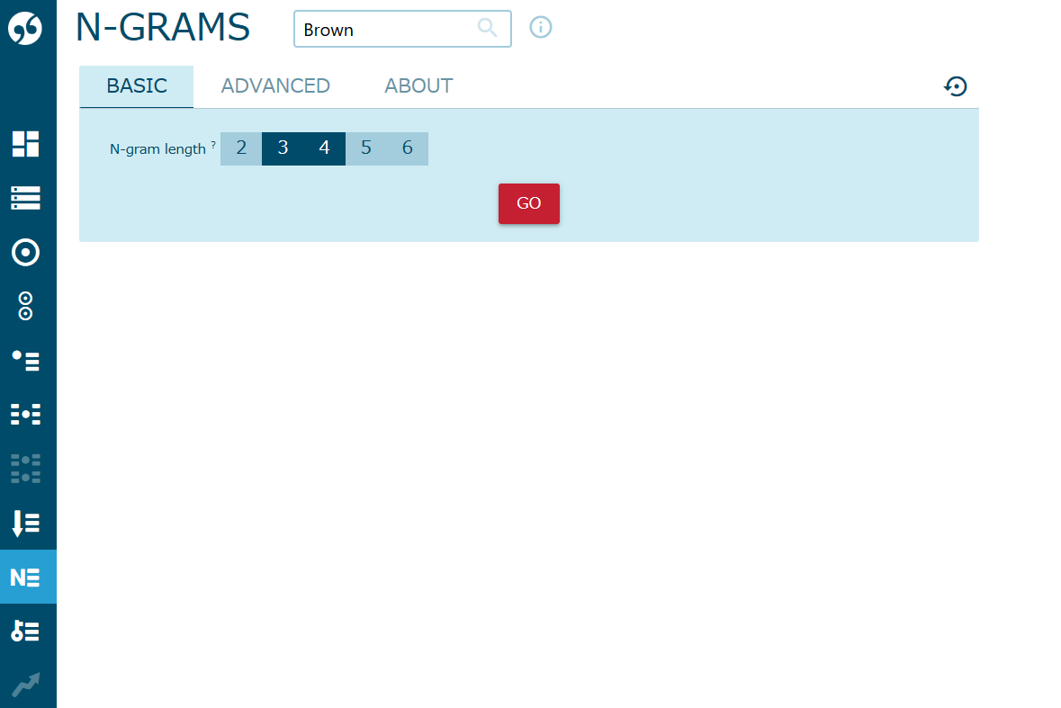
Fig 2: Sketch Engine N-Grams Screen for Brown corpus.

Explore this feature with a partner and take notes of different N-Grams that you haven’t seen before from two different corpora. Are any of these in today’s texts? Make sure to copy your partner’s work!

Corpus
1 | 2 | 3
4 | 5 | 6

Discussion

Did you find anything surprising in today’s lesson? If so, what? If everything was as expected, why?

Which skill or strategy was the most useful to you today? Which skill or strategy has been the most useful so far?

In your reading outside class, which skills or strategies do you use most often?

10. Language change

All languages change over time. What does your class know about this topic?

We know | We think | We want to know

Today you will:
- use collocation to guess synonyms;
- learn more about collocation;
- learn about colligation; and,
- Use previously studied skills and strategies.

Collocation for synonyms
You have looked at collocations before in order to guess synonyms. This time think about the word you know that has a few synonyms. You can use this to predict some of the possible meanings of the unknown word in your texts.

Here are two examples:

- In actual fact, she was distinctly perturbed by the man’s tone.

You probably know ‘distinct’ and ‘distinctly’ as well as ‘tone’. What do you think ‘perturbed’ means?

- I was struck by the glacial pace of their work.

You probably know ‘pace’. What does glacial mean in this example?

Next, try some of the unknown vocabulary in today’s texts.

Colligation

Colligation is the type of grammar that is often used with a word or phrase. Think of it as a grammar collocation. What grammar patterns do you think are used before or after these N-Grams from the British Academic Corpus?

of the
to be
that the
such as
due to

Next, check your ideas in Sketch Engine.

Discussion
What did you learn about language change?

Did you read anything that you disagree with?

Have you changed the way you think about language? Tell us more about your answer

11. Business 2

What do you remember about how business texts are organised?

What are N-Grams? Can you remember some that you found before?

Today you will:
- take notes from long texts;
- learn about T-units (sense groups); and,
- Use previously studied skills and strategies.

Taking notes from long texts
On the note template for this course, you have been taking keyword notes. To take notes for a long text it is useful to arrange these by paragraph. Add numbers for each paragraph as you take keyword notes. When you come to write your summary, it should be easy to organise your thoughts in paragraph order.

Here is an example of some notes on an article about language change, which you studied last week.

1. Proto Indo-European  (PIE)  Asia: westward  base many lang.  e.g. Sanskrit, Russian, English  2. reasons  separate communities  different dialects  reflect regional features | PIE started in Asia and moved westward. It formed the basis of several languages, including Sanskrit, Russian and English.  Some reasons it separated into several different languages are that people formed separate communities in vastly different locations. These communities had different dialects that reflected different regional features.

Use this system with today’s texts and share knowledge with your classmates.

T-units

T-units work like mini theme-rheme units within longer sentence constructions. As a heuristic (very rough rule) think of each T-unit as one mini-sentence within a sentence.

Separate these sentences into different T-units with slashes (/).

Examples:

Due to the launch of our new product at the end of this year/, we predict a substantial increase in retail sales as well as corporate sales.

One of the biggest problems we are likely to encounter as a business/ that operates across three continents/ is the standardisation of practices across all regions,/ Mina Hassan, Chief Operation Officer stated today in a shareholder’s meeting.

The hairdryer was recalled/ because there was a fault in the wiring/ although no consumers have reported finding problems with the product.

- One of the items for discussion, which is listed in the agenda, is planning for next week’s meeting with staff from the Malaysian office.
- It would be advantageous to make a list and rank each item according to its time sensitivity.
- There have been problems in securing a stable warehousing solution for our imports due not only to the space requirements but also the refrigeration requirements necessary to ensure stock spoilage is avoided.
- Should you encounter any difficulties with the software after installation, please contact our customer service team by email or telephone using the details provided on the reverse side of your licence key.
- We would appreciate it if you could send all banking details such as International Bank Account Number (IBAN), SWIFT code, reason for funds transfer, and the amount of currency remitted.

Next take a look at the texts from today. Which sentence in each text has the largest and smallest number of T-units?

Discussion

What features did you find in the business texts today? Are they different from the business texts two weeks ago?

Did you find any new collocations or colligations in today’s texts?

Which strategy was most helpful to understand the texts today? Why?

12. News

What topics are in the news right now? Generally speaking, are they positive or negative?

Today you will:
- use text organisation to summarise quickly;
- learn about discourse prosody; and,
- use previously taught skills and strategies.

Text organisation

What do you know about the structure of news articles?

After you read the first text, look at its paragraph lengths, theme/rheme patterns, number of T-units and other features you can think of or notice.

Appraisal

In a text, and especially in a collection of texts, there can often be a clear point of view available. This is called this appraisal. You can understand the writer’s judgement of a topic based on the words they use and their collocations. This can be even clearer when looking at a large corpus collected from the same type of texts. In the news articles you have read today, what are the different subjects you read about? What are the writers appraisals? How do you know this?

1
2
3

Discussion
Which text was most difficult to read? Why? What strategies or skills did you use to minimise the difficulty?

Were there any of the news articles that you disagreed with or that made you feel negative emotions? Why do you think that was?

Next week is your end-of term review so please make sure that you study everything carefully.

13. Game rules

Today your teacher will give you game rules to read. Use all of the strategies you have learned so far to play the game in the next lesson, which is the final lesson of the semester. It is still an important lesson, because you can see how well you understood the text according to how easy it is to understand the actions you must take in the game. You can also talk about developing your skills with your teacher individually.

PhAVE List from: Garnier, M., & Schmitt, N. (2014). The PHaVE List: A pedagogical list of phrasal verbs and their most frequent meaning senses. Language Teaching Research. doi: 10.1177/13621688145597988. Retrieved from https://eflnotes.wordpress.com/english-wordlists/

